
RAMAIAH
INSTITUTE OF TECHNOLOGY
USN | 1 | M | S

(Autonomous Institute, Affiliated to VTU)
(Approved by AICTE, New Delhi & Govt. of Karnataka) Accredited by NBA & NAAC with ‘A’ Grade

SUPPLEMENTARY SEMESTER EXAMINATIONS – JULY/AUGUST 2018

Course & Branch | : | B.E. : Electrical and Electronics Engineering. | Semester | : | V
Subject | : | Control Systems | Max. Marks | : | 100
Subject Code | : | EE52/EE502 | Duration | : | 3 Hrs

Instructions to the Candidates:
- Answer one full question from each unit

 |  | UNIT- I
1. | a) | Obtain i) F-V and ii) F-I analogous circuit of the following mechanical system given in Fig.1(a).  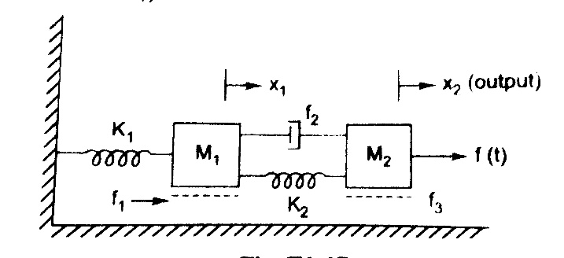  Fig.1(a) | CO1 | (10)
 | b) | Derive transfer function of field controlled DC servo motor. | CO1 | (10)
2. | a) | Differentiate open loop and closed loop systems with at least 3 examples for each. | CO1 | (08)
 | b) | Obtain i) F-V and ii) F-I analogous circuit of the following mechanical system given in Fig 2. (b).  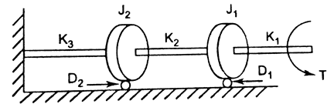  Fig.2(b). | CO1 | (12)
 |  | UNIT- II
3. | a) | A unity feedback system has and. Determine  - Steady-state error for k=1  - Value of K to reduce the error by 6%. | CO2 | (06)
 | b) | 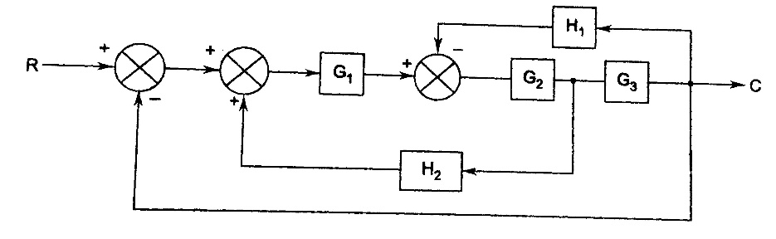  Reduce the above block diagram to single TF. | CO2 | (06)
 | c) | The unit step response of a second-order control system is given as . Determine the damping ratio and undamped frequency of oscillations. | CO2 | (08)
4. | a) | Consider a unity feedback system with a closed TF:  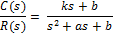  Determine the open-loop TF G(s). Show that the steady-state error with unit ramp input is given as . | CO2 | (08)
 | b) | Find: (i)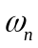 (ii) (iii) 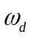 (iv) t_{r} (v) t_{p} (vi) M_{p} (vii) t_{s} and (viii) c(t) for unit step input for the system having T.F 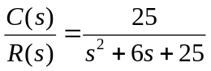 | CO2 | (08)
 | c) | The forward path TF of a unity feedback control system is given by: 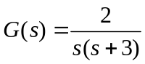 Obtain the expression for unit step response of the system. | CO2 | (04)
 |  | UNIT- III
5. | a) | A negative unity feedback system is having OLTF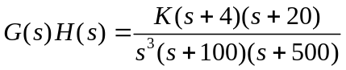. Find the range of K from RH criterion for which system stable. | CO3 | (08)
 | b) | A system having OLTF 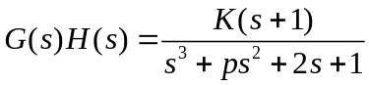, oscillates with frequency 2 rad/sec. Find values of ‘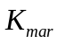’and ‘p’ if system is stable. | CO3 | (12)
6. | a) | Consider a fourth-order system with the C.E. , state whether the system is stable or not. | CO3 | (06)
 | b) | What are the difficulties in R-H stability criterion? Explain how you can overcome them. | CO3 | (06)
 | c) | Sketch the root locus plot of the system whose OLTF is given as 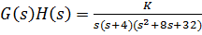. Comment on its stability. | CO3 | (08)
 |  | UNIT- IV
7. | a) | Draw the polar plot of:  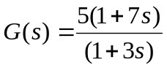 | CO4 | (08)
 | b) | Sketch the Nyquist plot and determine the stability of the following open loop transfer function of unity feedback control system 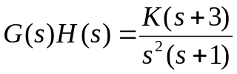 . | CO4 | (12)
8. | a) | A unit step input is applied to unity negative feedback system having OLTF 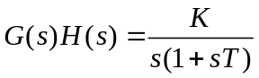.  Determine K and T to have peak overshoot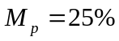 and resonant frequency 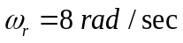. Also find resonant peak 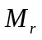 | CO4 | (10)
 | b) | Using Nyquist stability criterion, investigate the stability of closed loop system whose OLTF is 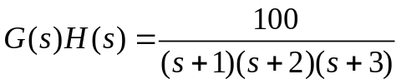. | CO4 | (10)
 |  | UNIT- V
9. | a) | Draw the Bode plot for the following system and comment on the stability. Find GM and PM.  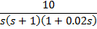 | CO3 | (14)
 | b) | Explain the need for designing of a compensator with one practical example. | CO5 | (06)
10. | a) | Define :  - Gain Margin  - Phase margin of a system. Hence mention the conditions for stability of a system. | CO3 | (08)
 | b) | Obtain the transfer function of the system whose Bode plot is as shown in Fig.10(b)  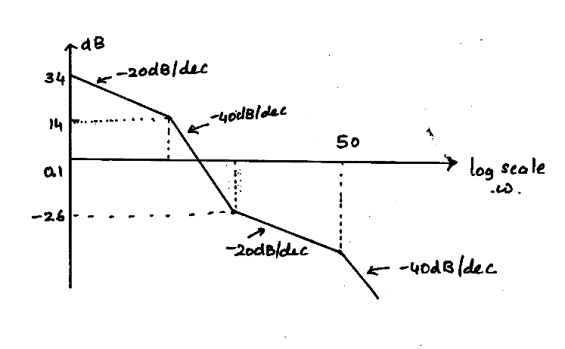  Fig.10(b) | CO3 | (12)

****************

